**AUTOCORRELATION BASED SPECTRUM SENSING OF FBMC SIGNAL**

**ABSTRACT**

The focus of this paper is on a feature detector for filter bank multicarrier (FBMC) signal in cognitive radio. In this paper, we first prove that the FBMC signal samples are uncorrelated with each other. However, if the FBMC signal is processed by our proposed method, then the autocorrelation function (ACF) of FBMC signal becomes non-zero at the lag equal to number of subcarriers. On the other hand, additive white Gaussian noise (AWGN) samples after the same proposed processing remain uncorrelated. Using this feature, an autocorrelation based feature detector is proposed to detect FBMC signal in noise.

The main advantage of the proposed detector is that, unlike blind detectors, this detector can distinguish between FBMC signal and noise (or interference). Next, the distribution of the test statistic of the proposed detector is derived under noise-only scenario so that the threshold of the Neyman-Pearson detector can be designed to maintain constant false alarm rate while maximizing the probability of detection. Simulation results demonstrate the efficacy of the proposed detector.

**CHAPTER 1**

**INTRODUCTION**

Orthogonal Frequency Division Multiplexing (OFDM) has been a dominant technology in 4G LTE-Advanced. However, OFDM might be a misfit for future generation cellular technologies such as 5G and cognitive radios due to some disadvantages such as loss in spectral efficiency due to cyclic prefix (CP) insertion, high out-of-band radiation and sensitivity to narrowband interferers. As shown in main outcomes of EU research projects 5GNOW and PHYDYAS, filter bank multicarrier (FBMC) is a promising alternative to OFDM for 5G and cognitive radios, respectively. FBMC uses well designed bank of filters with minimum out-of-band radiation and no use of CP means significant improvement in the spectral efficiency.

Spectrum sensing is one of the most important tasks in cognitive radios. In the traditional cognitive radio standards, the main problem has been to detect the presence of primary (licensed or legacy) user using incumbent geolocation databases and spectrum sensing techniques. However, the challenging problem of heterogeneous secondary coexistence has garnered very less attention in the cognitive radio standards and related literature. Since 5G will involve multitier heterogeneous networks in heterogeneous bands (licensed as well as unlicensed), acquiring spectrum awareness regarding the secondary users is equally important.

Moreover, the use of new waveforms in 5G PHY will necessitate design of the spectrum sensing algorithms for the new candidate waveforms. As FBMC is one of the few most potential candidates for 5G waveform, sensing and distinguishing FBMC signal is a very relevant problem. As such, the focus of this paper is on proposing spectrum sensing scheme for FBMC signal. In spectrum sensing literature, most of the detection schemes have been designed for OFDM signal and there is a dearth of research on spectrum sensing of FBMC signal.

Although blind detection techniques such as energy detection can be used to detect any waveform, they cannot distinguish between noise and interfering signal. In addition they have serious issues such as SNR walls, a feature detector was proposed based on the induced repeating patterns in the transmitted FBMC signal. Thus there is a dearth of feature detectors for FBMC signal in the spectrum sensing literature. With this as motivation, a feature detector is proposed in this paper which can distinguish between FBMC-plus-noise and noise-only scenarios. Also unlike, no attempt is being made to induce patterns in the basic FBMC transmission.

The specific contributions of this paper are:

* It is shown that the autocorrelation function (ACF) of the FBMC signal is zero for non-zero lags.
* After proper study of FBMC signal generation, a method is proposed to process the FBMC signal at the receiver so that the processed FBMC signal has non-zero ACF value at a certain lag value other than zero. On the other hand, if the same processing is applied to AWGN samples, the processed noise samples remain uncorrelated.
* A spectrum sensing scheme is proposed to detect the differences in ACF behavior of the processed (or modified) data in the two scenarios of FBMC-plus-noise and noiseonly.
* The conditional distribution of the proposed test statistic, conditioned on the received signal being only noise, is derived so that the threshold for Neyman-Pearson detector can be evaluated analytically

OFDM has been researched and deployed for broadband wired and wireless communications for the past two decades. OFDM is widely adopted because of a number of advantages that it offers: Orthogonality of subcarrier signals that allows

* Trivial generation of transmit signal through an inverse fast Fourier transform (IFFT) block
* Trivial separation of the transmitted data symbols at the receiver through a fast Fourier transform (FFT) block
* Trivial equalization through a scalar gain per subcarrier
* Trivial adoption to multiple-input multiple-output (MIMO) channels.

AN IEEE SIGNALS PROCESSING MAGAZINE MAY 2011

* Closely spaced orthogonal subcarriers partition the available bandwidth into a maximum collection of narrow sub bands.
* Adaptive modulation schemes can be applied to subcarrier bands to maximize bandwidth efficiency/transmission rate.
* The very special structure of OFDM symbols simplifies the tasks of carrier and symbol synchronizations.

These points are well understood and documented in the literature. On the other hand, multiple-access OFDM or orthogonal frequency division multiple accesses (OFDMA) have been recently proposed in a number of standards and proprietary waveforms. Some particular forms of OFDMA have also been proposed for cognitive radio systems. In OFDMA, each user is allocated a subset of subcarriers. To prevent intercarrier interference (ICI), the users’ signals must be synchronized at the receiver input (but not necessarily at the transmitters’ outputs).

Considering this point, one may note that OFDMA only works well in the network downlink of a base station, where all of the subcarriers are transmitted from the same point (the base station) and hence can be easily synchronized and undergo the same Doppler frequency shift before reaching each receiver. However, synchronization is not trivial in the uplink where a number of nodes are transmitting separately.

Since, in practice, perfect synchronization in the uplink of an OFDMA network may not be possible, additional signal-processing steps have to be taken to minimize interference among signals from different nodes. Such steps add significant complexity to an OFDMA receiver; see and the references therein. The problem is worse in a cognitive radio setting where both primary (noncognitive nodes) and secondary users (cognitive nodes) transmit independently and may be based on different standards.

In such a setting, the only way that one may adopt to separate the primary and secondary user signals is through a filtering mechanism. OFDM is thus a poor fit because the filters associated with its synthesized subcarrier signals (at the transmitter) and analyzed subcarrier signals (at the receiver) have relatively large side lobes and such lobes will result in leakage of signal powers among the bands of different users. Although suggestions have been made to improve the side lobes of OFDM analysis and synthesis filters through the use of filtered OFDM (discussed later) and other methods, these solutions are generally very limited in performance.

Furthermore, data transmissions over digital subscriber lines (DSLs) and power line communication (PLC) technologies often use unshielded wires and thus become a source and victim of electromagnetic interference. This is similar to the case of OFDMA and cognitive radios, where each transmission can be established over certain portions of a broadband, and spectral activities over the rest of the band should be avoided to allow coexistence with radio communication activities within the band of interest.

The above problems could be greatly alleviated if the filters that synthesize/analyze the subcarrier signals had small side lobes. An interesting, but apparently not widely understood, fact is that the first multicarrier technique developed before the invention of OFDM used filter banks for the synthesis and analysis of multicarrier signals. Such filter banks can be designed with arbitrarily small side lobes and, therefore, are an ideal choice in multiple access and cognitive radio applications as well as broadband data transmission over unshielded wires.

The goal of this article is to present a tutorial review of FBMC techniques and compare them with OFDM in various applications. We note that most of the advantages of FBMC originate from the fact that, by design, the nonadjacent subcarriers in this modulation are separated almost perfectly through a bank of well-designed filters. OFDM, on the other hand, was originally designed with a great emphasis on a low-complexity implementation. Much of the low complexity of OFDM is due to a fundamental assumption: subcarrier signals are a set of perfectly synchronized orthogonal tones.

These tones are generated at the transmitter using an IFFT block, and they are separated at the receiver through an FFT block. Although this article highlights a number of limitations of OFDM in present and future communication systems, the author has no intention of ignoring the many important and desirable features of OFDM that were itemized at the beginning of this section. The intention is to emphasize the fact that OFDM, although widely adopted in the present industry, is not necessarily the best solution in many future communication systems, particularly in multiple access and cognitive radio networks where FBMC may be found more appealing.

At the same time, the limitations of FBMC will be noted. For instance, we note that while deployment of a MIMO technique in OFDM is a straightforward task, unfortunately, the development of MIMO-FBMC systems/networks is nontrivial and may be very limited. Moreover, while for many applications, FBMC may be more complex than OFDM, there are cases where the added steps to undo the undesirable features of OFDM may lead to systems that are more complex than their FBMC counterparts.

This article is organized as follows. To draw a connection between OFDM and FBMC, a unified filter bank formulation that is applicable to both is presented in the section “A Unified Formulation for OFDM and FBMC.” This formulation shows that the prototype filter based on which an OFDM signal is synthesized/analyzed has to obey certain constraints, and it is these constraints that result in the undesirable performance of OFDM in the applications discussed those that we further discuss in this article. Filtered OFDM, a modified OFDM that has been designed to improve on the spectral containment of subcarrier signals, is then presented and discussed in detail in the section “Filtered OFDM.” This presentation shows some of the serious limitations of a filtered OFDM in restricting the spectra of desired subcarriers to any band of interest.

FBMC systems are reviewed in the section “Filter Bank Multicarrier.” This presentation is structured to clearly show the spectral advantages of FBMC over OFDM. The applications of multicarrier techniques are reviewed in the section “Applications.” This section is organized to highlight the pros and cons of both OFDM and FBMC systems in a variety of current and future applications. To present the basic ideas behind OFDM and FBMC methods, without getting too far into the details, the presentations in sections “A Unified Formulation for OFDM and FBMC,” “Filtered OFDM,” and “Filter Bank Multicarrier” ignore some parts of the literature.

As wireless transceivers find an ever increasing number of applications the efficient allocation of spectrum has become an important topic. Many portions of the radio spectrum are unregulated, leading to interference among competing users. Large portions of spectrum have been licensed to a single user. This leads to large chunks of spectrum that are unused at various times, in different geographical locations, or in some subset of the spectrum, when the primary user (PU) which holds a license does not use it.

As demand for wireless spectrum increases, more efficient spectrum allocation is needed. DSA networks will allow cognitive radios to dynamically allocate unused spectrum, and to assign it among various users in the network. Allowing transceivers to operate in this manner introduces several security concerns. Selfish users can transmit outside their allowed bandwidth, power levels, or time intervals. This could cause interference to others in the DSA network, and to licensed PUs.

For these reasons it is useful to identify and track cognitive radio transmitters to enforce spectrum access rules. It is desirable that no modifications are made to the PU’s transmission so that compatibility is maintained with the PU systems which already hold licenses. While typical security identifiers, such as MAC addresses or encryption keys, could serve this purpose, they can be stolen (in the case of encryption keys) or easily forged (for MAC addresses), and introduce overhead to the system to track and revoke identities.

In the past, orthogonal frequency division multiplexing (OFDM) has enjoyed its dominance as the most popular signaling method in broadband wired and wireless channels. OFDM has been adopted in the broad class of DSL standards as well as in the majority of wireless standards, for example, variations of IEEE 802.11 and IEEE 802.16, 3GPP-LTE, and LTE-Advanced. OFDM is known to be a perfect choice for point-to-point communications, for example, from a base station to a mobile node and vice versa. It offers a minimum complexity and achieves very high bandwidth efficiency.

However, it has been noted that OFDM has to face many challenges when considered for adoption in more complex networks. For instance, the use of OFDM in the uplink of multiuser networks, known as OFDMA (orthogonal frequency division multiple access), requires full synchronization of the users’ signals at the base station input. Such synchronization was found to be very difficult to establish, especially in mobile environments where Doppler shifts of different users are hard to predict have noted that carrier and timing synchronization represents the most challenging task in OFDMA systems.

To combat the problem, some researchers have relaxed on the need for a close to perfect carrier synchronization among users and have proposed multiuser interference cancellation methods. These methods are generally very complex to implement. Their implementation increases the receiver complexity by orders of magnitude. Hence, one of the main advantages of OFDM, the low complexity, will be lost.

Another limitation of OFDM appears when attempt is made to transmit over a set of noncontiguous frequency bands, known as*carrier aggregation*. The poor response of the subcarrier filters in IFFT/FFT filter banks of OFDM introduces significant out-of-band*egress noise* to other users and also picks up significant*ingress noise* from them. The same problem appears if one attempts to adopt OFDM for filling in the spectrum holes in cognitive radios. Methods of reducing OFDM spectral leakage prove to be very limited in performance and may add significant complexity to the transmitter.

For instance, the side lobe suppression techniques, can achieve an out-of-band emission suppression of only 5 to 10 dB, while they may add significant complexity to the transmitter and they will incur some loss in bandwidth efficiency.

Filter bank multicarrier (FBMC) is an alternative transmission method that resolves the above problems by using high quality filters that avoid both ingress and egress noises. Also, because of the very low out-of-band emission of subcarrier filters, application of FBMC in the uplink of multiuser networks is trivia. It can be deployed without synchronization of mobile user nodes signals. In the application of cognitive radios, the filter bank that is used for multicarrier data transmission can also be used for spectrum sensing.

On the other hand, compared to OFDM, FBMC falls short in handing multiple-input multiple-output (MIMO) channels, although a few solutions to adopt FBMC in MIMO channels have been reported in the literature. Nevertheless, as our recent research, in the emerging area of*massive* MIMO, FBMC is found as powerful as OFDM and in some cases superior to OFDM.

In the past, many attempts have been made to adopt FBMC in various standards. Apparently, the earliest proposal to use FBMC for multicarrier communications is a contribution from Tzannes et al. of AWARE Inc., in one of the asymmetric digital subscriber lines (ADSL) standard meetings.

The proposed method that was called discrete wavelet multitone (DWMT) was further studied. Despite enthusiasm from the research community and the cited references therein), DWMT was not adopted in the ADSL standard. This was partly because of the perceived complexity of this method as compared to its rival, DMT (discrete multitone, an equivalent name for OFDM in DSL literature). Indeed, the DWMT structure proposed by Tzannes et al. was significantly more complex than that of DMT.

The major part of the complexity of DWMT came from the equalization method that was adopted. The detailed discussion presented assumed that one needs an equalizer that combines signals from each subcarrier band and its adjacent bands. Typical equalizer lengths suggested were 21 real-valued taps per subcarrier. It was later noted by the author of this paper that if each subcarrier is sufficiently narrow such that it can be approximated by a flat gain, two real taps per subcarrier would be sufficient for equalization.

This observation led to further study of DWMT. In power line communications (PLC) community, it has been named wavelet OFDM and was adopted in the IEEE P1901 standard. The main motivation for use of DWMT in DSL and its adoption later in PLC was to deal with ingress and egress noises, since both DSL and PLC use unshielded copper lines that are subject to strong radio interference. Moreover, in 1999, an FBMC method with nonoverlapping subcarrier bands was proposed as a solution for filtering the narrow-band interferences in very high-speed DSL (VDSL) channels.

The proposed method was called filtered multitone (FMT). This proposal that was included as an annex in one of the initial draft documents of VDSL was further developed by a number of researchers. However, to avoid incompatibility with ADSL, FMT was not included in the final document of the VDSL standard. Another unsuccessful story is an attempt by France Telecom to introduce FBMC in the IEEE 802.22, a cognitive radio standard to access TV bands in wireless rural area networks (WRAN). Up to now, apparently, the only standard for radio transmission that uses FBMC is the TIAs Digital Radio Technical Standard.

Recent discussions on the fifth generation (5G) wireless communications have initiated a much stronger wave of interest in deviating from the main stream of OFDM systems. This shift of interest is clearly due to limitations of OFDM in the more dynamic and multiuser networks of future.

A number of proposals have been made to adopt new waveforms with improved spectral containment. A good example of such activity is the 5GNOW project in Europe which challenges LTE and LTE-Advanced in coping with the dynamic needs of 5G. The 5GNOW has identified four alternative choices of waveforms to better serve 5G needs. These waveforms that are all built based on some sort of filtering may be thought as adoptions of FBMC method to suit different needs of various applications.

We refer interested readers to the documents available at [http://www.5gnow.eu](http://www.5gnow.eu/) for the details of the proposed waveforms by the 5GNOW group. Another major activity that has performed a broad study of FBMC is due to the PYHDYAS project (also in Europe). The PHYDYAS contributors have published heavily on various aspects of FBMC; including prototype filter design, equalization, synchronization, and application to MIMO channels. A summary of the major findings of the PHYDYAS contributors is presented, and a complete list of their publications can be found at [http://www.ict-phydyas.org](http://www.ict-phydyas.org/).

The main thrust of this paper is to present a point of view of FBMC and its future applications as seen by the author. While we acknowledge the presence of a large body of works on FBMC, the paper details are geared towards the research outcomes of the author and his students in past 15 years. The paper emphasis is on the recent works of the author and his students. Many shortcomings of OFDM in dealing with the requirement of the next generation of wireless systems are discussed and it is shown how FBMC overcomes these problems straightforwardly.

We present a derivation of FBMC systems that reveals the relationships among different forms of FBMC. A method of designing FBMC systems for a near-optimum performance in doubly dispersive channels is presented and its superior performance over OFDM is shown. The example considered is an underwater acoustic channel. Application of FBMC technique to massive MIMO communications is introduced and its advantages in this emerging technology are revealed. Last, but not the least, the problems of channel equalization and synchronization in FBMC systems are also given a special treatment and a number of outstanding research problems in this field, for future studies, are identified.

**CHAPTER 2**

**LITERATURE REVIEW**

**[1] G. Wunder, P. Jung, M. Kasparick, T. Wild, F. Schaich:** This article provides some fundamental indications about wireless communications beyond LTE/LTE-A (5G), representing the key findings of the European research project 5GNOW. We start with identifying the drivers for making the transition to 5G networks. Just to name one, the advent of the Internet of Things and its integration with conventional human-initiated transmissions creates a need for a fundamental system redesign.

Then we make clear that the strict paradigm of synchronism and orthogonality as applied in LTE prevents efficiency and scalability. We challenge this paradigm and propose new key PHY layer technology components such as a unified frame structure, multicarrier waveform design including a filtering functionality, sparse signal processing mechanisms, a robustness framework, and transmissions with very short latency. These components enable indeed an efficient and scalable air interface supporting the highly varying set of requirements originating from the 5G drivers.

**Summary:** 5GNOW: non-orthogonal, asynchronous waveforms for future mobile applications

**[2] B. Farhang-Boroujeny:** Recent discussions on viable technologies for 5G emphasize on the need for waveforms with better spectral containment per subcarrier than the celebrated orthogonal frequency division multiplexing (OFDM). Filter bank multicarrier (FBMC) is an alternative technology that can serve this need. Subcarrier waveforms are built based on a prototype filter that is designed with this emphasis in mind. This paper presents a broad review of the research work done in the wireless laboratory of the University of Utah in the past 15 years. It also relates this research to the works done by other researchers. The theoretical basis based on which FBMC waveforms are constructed is discussed.

Also, various methods of designing effective prototype filters are presented. For completeness, polyphase structures that are used for computationally efficient implementation of FBMC systems are introduced and their complexity is contrasted with that of OFDM. The problems of channel equalization as well as synchronization and tracking methods in FBMC systems are given a special consideration and a few outstanding research problems are identified.

Moreover, this paper brings up a number of appealing features of FBMC waveforms that make them an ideal choice in the emerging areas of multiuser and massive MIMO networks.

**Summary:** Filter bank multicarrier modulation: A waveform candidate for 5G and beyond

**[3] B. Sujitha Gowri, Dr. P. Ramana Reddy:** OFDM is the basic multi carrier modulation technique for both wireless and cellular communications. OFDM is a perfect choice for point-to-point communication, which offers minimum complexity and achieves very high bandwidth. However, it has several challenges such as, limited spectral efficiency and large out of band emissions. In order to overcome these challenges, there are several modulation techniques being developed in these days, among these Filter Bank Multi Carrier (FBMC) is one of the techniques.

This paper describes about Power Spectral Density (PSD) and Bit Error Rate (BER) of the FBMC and conventional Cyclic Prefix (CP) based Orthogonal Frequency Division Multiplexing (OFDM) systems under Additive White Gaussian Noise (AWGN) channel. FBMC technique has less out of band emissions as a result of less number of side lobes. Meanwhile, the omission of CP improves the bandwidth efficiency of the system.

**Summary:** FBMC-New Multicarrier Modulation Technique

**[4] S. Chaudhari:** Inefficient use of radio spectrum is becoming a serious problem as more and more wireless systems are being developed to operate in crowded spectrum bands. Cognitive radio offers a novel solution to overcome the underutilization problem by allowing secondary usage of the spectrum resources along with high reliable communication. Spectrum sensing is a key enabler for cognitive radios. It identifies idle spectrum and provides awareness regarding the radio environment which are essential for the efficient secondary use of the spectrum and coexistence of different wireless systems.

The focus of this thesis is on the local and cooperative spectrum sensing algorithms. Local sensing algorithms are proposed for detecting orthogonal frequency division multiplexing (OFDM) based primary user (PU) transmissions using their autocorrelation property.

The proposed autocorrelation detectors are simple and computationally efficient. Later, the algorithms are extended to the case of cooperative sensing where multiple secondary users (SUs) collaborate to detect a PU transmission. For cooperation, each SU sends a local decision statistic such as log-likelihood ratio (LLR) to the fusion center (FC) which makes a final decision. Cooperative sensing algorithms are also proposed using sequential and censoring methods. Sequential detection minimizes the average detection time while censoring scheme improves the energy efficiency.

The performances of the proposed algorithms are studied through rigorous theoretical analyses and extensive simulations. The distributions of the decision statistics at the SU and the test statistic at the FC are established conditioned on either hypothesis. Later, the effects of quantization and reporting channel errors are considered. Main aim in studying the effects of quantization and channel errors on the cooperative sensing is to provide a framework for the designers to choose the operating values of the number of quantization bits and the target bit error probability (BEP) for the reporting channel such that the performance loss caused by these non-idealities is negligible.

**Summary:** Spectrum sensing for cognitive radios: Algorithms, performance and limitations

**[5] B. Gao, J.-M. Park, Y. Yang, and S. Roy:** With the development of dynamic spectrum access technologies, such as cognitive radio, the secondary use of underutilized TV broadcast spectrum has come a step closer to reality. Recently, a number of wireless standards that incorporate CR technology have been finalized or are being developed to standardize systems that will coexist in the same TV white spaces. In these wireless standards, the widely studied problem of primary-secondary network coexistence has been addressed by the use of incumbent geolocation databases augmented with spectrum sensing techniques.

However, the challenging problem of secondary-secondary coexistence-in particular, heterogeneous secondary coexistence- has garnered much less attention in the standards and related literature. The coexistence of heterogeneous secondary networks poses challenging problems due to a number of factors, including the disparity of PHY/MAC strategies of the coexisting systems.

In this article, we discuss the mechanisms that have been proposed for heterogeneous coexistence, and propose taxonomy of those mechanisms targeting TVWSs. Through this taxonomy, our aim is to offer a clear picture of the heterogeneous coexistence issues and related technical challenges, and shed light on the possible solution space.

**Summary:** A taxonomy of coexistence mechanisms for heterogeneous cognitive radio networks operating in TV white spaces

**CHAPTER 3**

**EXISTING METHOD**

**Energy detection:**

Although blind detection techniques such as energy detection, can be used to detect any waveform, they cannot distinguish between noise and interfering signal. If no enough information is available about the primary user signal, which is usually the case in a CR environment, energy detection can be used. This can be done simply by band-pass filtering the required bandwidth, then squaring and integrating the output over the observation interval, and then the result is compared with a certain threshold to decide whether a primary user is present or not .

It is a non-coherent and non-cooperative detection method that detects the primary signal based on the sensed energy. Due to its simplicity and no requirement on a priori knowledge of primary user signal, energy detection (ED) is the most popular sensing technique in cooperative sensing. The block diagram for the energy detection technique is shown in the below figure.

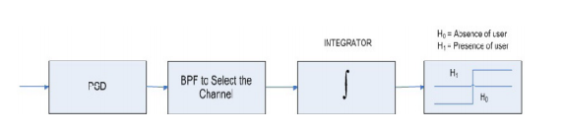

**Figure: Existing Block Diagram**

The block diagram for the energy detection technique is shown in the Figure 5. In this method, signal is passed through band pass filter of the bandwidth W and is integrated over time interval. The output from the integrator block is then compared to a predefined threshold. This comparison is used to discover the existence of absence of the primary user. The threshold value can set to be fixed or variable based on the channel conditions.

The ED is said to be the Blind signal detector because it ignores the structure of the signal. It estimates the presence of the signal by comparing the energy received with a known threshold ν derived from the statistics of the noise. Analytically, signal detection can be reduced to a simple identification problem, formalized as a hypothesis test.

In this method, signal is passed through band pass filter of the bandwidth W and is integrated over time interval. The output from the integrator block is then compared to a predefined threshold. This comparison is used to discover the existence of absence of the primary user. The threshold value can set to be fixed or variable based on the channel conditions. Energy Detection is the most common way of spectrum sensing because of its low computational and implementation complexities.

It is a more generic method as the receivers do not need any knowledge on the primary user’s signal. The signal is detected by comparing the output of the energy detector with a threshold which depends on the noise floor. The received signal sample of a secondary user can be represented as

Z:\2020-1\Autocorrelation\2.PNG

Where n denotes the sample index, h(n) denotes the impulse response of the channel between the primary and secondary users, s(n) is the signal from the primary user, w(n) denotes zero-mean additive white Gaussian noise and H0 and H1 represent hypothesis corresponding to the absence and presence of the primary user’s signal, respectively. We consider the use of energy detection for the spectrum sensing. Then, the probability of false alarm and probability of detection for the energy detector can be represented as

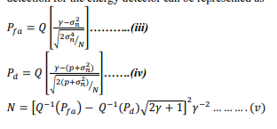

Where N is the number of samples, Q is the standard Gaussian complementary cumulative distribution function, p is the average signal power, σn 2 is the noise variance and γ is the threshold level to be determined The output γ of the detector is compared to a threshold to make the right decision:

If γ ≥ threshold then PU signal is present.

If γ < threshold then PU signal is absent.

Where is defined as

Z:\2020-1\Autocorrelation\4.PNG

The important challenge with the energy detector based sensing is the selection of the threshold for detecting primary users. The other challenges include inability to differentiate interference from primary users and noise and poor performance under low signal-to-noise ratio values.

Pd (probability of detection) and Pfa (probability of false alarm) are the important factors for energy based detection which gives the information of the availability of the spectrum.

**Decision Threshold**

The decision threshold and the noise uncertainty (in turn the SNR and SNR Wall) are key parameters in the performance of the energy detector. The value of the decision threshold λ can be chosen for an optimal compromise between Pfa and Pd. This method requires prior knowledge about the noise and detected signal power, both of which are not easy to determine. Detected signal power is difficult to estimate primarily because of transmission and propagation characteristics which include fading possibly due to user movement and interference.

Setting the threshold just above the noise floor is typically employed for fixed threshold purposes, but this is not ideal since noise can change due to various reasons. Noise power is primarily due to white noise that varies with temperature fluctuations, inefficient low noise amplifiers in receivers and filters, or leakage of signals with small variations. High noise power that leads to low SNR values can cause sharp degradations in the energy detector performance due to the SNR wall.

The energy detector’s limitation is that it cannot differentiate signal types but can only determine the presence of the signal; therefore, the energy detector is prone to the false detection triggered by the unintended signals. The Pfa and Pd are related to each other through decision regions and likelihood functions.

**DISADVANTAGES:**

1. Noise and ACI affect the performance of the energy detector, a very poor performance at low SNR was observed.

2. The energy detector cannot differentiate signal types but can only determine the presence of the signal. Thus, the energy detector cannot differentiate between primary and secondary user signals. This makes it prone to false alarm when another secondary user attempts to access the same channel.

**CHAPTER 4**

**PROPOSED METHOD**

**Autocorrelation Detector:**

Moreover, the use of new waveforms in 5G PHY will necessitate design of the spectrum sensing algorithms for the new candidate waveforms. Proposed autocorrelation detector was proposed based on the induced repeating patterns in the transmitted FBMC signal., a feature detector is proposed in this paper which can distinguish between FBMC-plus-noise and noise-only scenarios. Also unlike no attempt is being made to induce patterns in the basic FBMC transmission. The specific contributions of this paper are:

It is shown that the autocorrelation function (ACF) of the FBMC signal is zero for non-zero lags. After proper study of FBMC signal generation, a method is proposed to process the FBMC signal at the receiver so that the processed FBMC signal has non-zero ACF value at a certain lag value other than zero. On the other hand, if the same processing is applied to AWGN samples, the processed noise samples remain uncorrelated.

A spectrum sensing scheme is proposed to detect the differences in ACF behaviour of the processed (or modified) data in the two scenarios of FBMC-plus-noise and noise only. The conditional distribution of the proposed test statistic, conditioned on the received signal being only noise, is derived so that the threshold for Neyman-Pearson detector can be evaluated analytically.

**FBMC SIGNAL STRUCTURE:**

FBMC is a multicarrier transmission technique that is an attractive alternative to the OFDM technique. In OFDM, FFT acts like a filter using rectangular window in time domain which amounts to frequency response at each subcarrier (or sub channel) being a sinc function. The sinc function has high side-lobes resulting in out-of-band ripples. In FBMC, in order to reduce the out-of-band ripples, the main-lobe of filter-frequency-response at each subcarrier is spreaded while side-lobes are reduced so that only adjacent subchannels are overlapping. In the figure, the even (or odd) indexed subchannels are separated and there is overlap between adjacent subcarriers.

As a result of spreading the main-lobe in frequency, the subcarriers are no longer orthogonal in FBMC as they were in OFDM. However, there are several advantages of this design: side-lobes are significantly lesser as compared to OFDM, no inter-channel-interference from all subcarriers (except from the immediate neighbors) as in OFDM in the presence of carrier frequency offset. The orthogonality between adjacent subchannels in FBMC can be achieved using offset quadrature amplitude modulation (OQAM) modulation technique. In this paper, we consider OQAM-FBMC implementation employed.

As overall frequency spread of the response has significantly reduced in FBMC, the impulse response of the filter spreads in time beyond one symbol period and the symbols overlap in time domain. The number of symbols that overlap in time domain is given by the parameter K, known as overlapping factor. In this paper, the overlapping factor considered is K = 3. The design of the prototype filter (or the first filter in the filter-bank) is based on Nyquist criterion as explained. Next, the filter bank is obtained by multiplying the prototype filter coefficients by e j2πln N where l is the index of l th filter in the bank and n is the index of input data element given to IFFT.

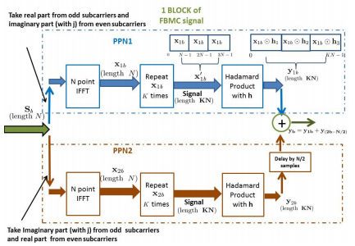

**Fig : FBMC block diagram: This figure shows the generation of bth block of data samples. Each input block (Sb) is of length N samples and output block (y1b or y2b) is of length KN samples. Output samples of PPN2 are delayed by N 2 samples and are added to ouput samples of PPN1 to give corresponding bth block output**

In OQAM technique, the real and imaginary parts of a complex symbol are delayed by half the symbol time and are not transmitted simultaneously, thus making the subcarriers orthogonal. The delay of half the symbol time introduced here reduces the capacity of the system.

Hence, to achieve full capacity the symbol rate is doubled and two poly-phase networks (PPNs) are employed for low-complexity implementation of OQAM-FBMC so that the size of IFFT block reduces from KN to N. As the focus of this paper is not to explain the efficient OQAM-FBMC implementation using PPNs, we direct interested readers for discussion on actual efficient implementations of OQAM-FBMC using PPNs.

Next, we explain the FBMC signal generation described and implemented , which is helpful in finding the structure in the FBMC signal, which in turn can be detected using a feature detector. Note that the implementation of weighted frequency spreading can be achieved by first loading every Kth subcarrier with data and then convolving with frequency response H (k) of prototype filter, where k is subcarrier index. In time domain, this is equivalent to repeating the time-domain data-block K times and then multiplying the resultant data vector of length KN with h.

This approach is used in this paper to generate the FBMC signal. The FBMC transmitter section, Complex QAM/PSK symbols, S[i], is fed to N-IFFT block of both PPN1 and PPN2 sections. In PPN1, real part of data is loaded on to sub-carriers of odd indices and imaginary part of data is loaded on to sub carriers of even indices. The PPN1 data vector corresponding to bth block is represented by x1b. On the other hand, in PPN2, imaginary part of data is loaded on to odd subcarriers and real part of data is loaded on to even subcarriers.

Each output block of KN samples of PPN1 and PPN2 overlap by N 2 samples and the samples are added to give the transmitted FBMC signal y[n].

Here, y[n] = y1 [n] + y2 [n − N/2]

Where y1 [n] and y2 [n] are the outputs of PPN1 and PPN2 sections, respectively.

**AUTOCORRELATION ANALYSIS OF FBMC SIGNAL:**

Note that the feature detector proposed in this paper is going to be implemented at the receiver. As this section focuses only on analysing the ACF for FBMC signal, we assume noise-free channel in this section so that the received as well as transmitted FBMC signals are same. We first start with ACF analysis of the received FBMC signal to show that the autocorrelation values at non-zero lags (τ is not equal to 0) are zero. Next, based on the study of FBMC signal generation, we propose the modification to the FBMC signal at the receiver such that autocorrelation values at τ = N become non-zero. This is followed by ACF analysis of modified FBMC signal at the receiver and derivation of closed form expression for the corresponding non-zero autocorrelation values at τ = N.

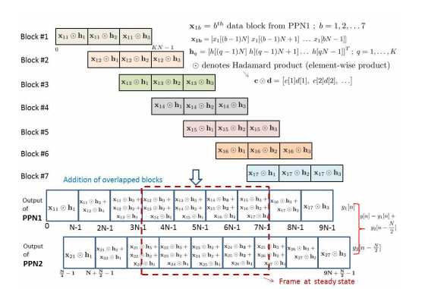

**Fig: Representation of FBMC frames structure. In this figure, generation of PPN1 is shown using blocks. Generation of PPN2 will be similar and only the resulting PPN2 frame is shown. Here, K = 3, number of blocks = 7.**

**CHAPTER 5**

**ADVANTAGES & APPLICATIONS**

**ADVANTAGES:**

* A Proposed autocorrelation detector which is the proposed method can distinguish between FBMC-plus-noise and noise-only scenarios.
* Proposed autocorrelation detector has good performance when compared to existing method.

**APPLICATIONS:**

* Spectrum sensing ,
* Resource allocation and scheduling.
* Power system line outage detection
* Bioinformatics
* Quality control

**CHAPTER 6**

**SOFTWARE REQUIREMENTS**

**What Is MATLAB?**

MATLAB is an elite dialect for specialized registering. It incorporates calculation, representation, and programming in a simple to-utilize condition where issues and arrangements are communicated in natural numerical documentation. Run of the mill utilizes incorporate

• Math and calculation

• Algorithm advancement

• Data obtaining

• Modeling, reenactment, and prototyping

• Data examination, investigation, and representation

• Scientific and designing illustrations

• Application advancement, including graphical UI building

MATLAB is an intuitive framework whose important records thing is an exhibit that doesn't require dimensioning. This allows you to address several specialized processing issues, specifically people with framework and vector data, in a small quantity of the time it might take to compose a program in a scalar non intuitive dialect, as an instance, C or FORTRAN.

The name MATLAB stays for grid studies facility. MATLAB modified into to start with composed to offer simple access to framework programming created thru the LINPACK and EISPACK ventures. Today, MATLAB vehicles fuse the LAPACK and BLAS libraries, putting the cutting element in programming for network calculation.

MATLAB has advanced over a time of years with contribution from several customers. In college situations, it's miles the same old educational system for early on and propelled courses in arithmetic, designing, and technological know-how. In industry, MATLAB is the tool of selection for high-profitability research, development, and exam.

MATLAB highlights a collection of extra utility-precise preparations called device booths. Important to most clients of MATLAB,

Tool kits allow you to examine and practice particular innovation. Tool compartments are exhaustive accumulations of MATLAB capacities (M-records) that extend out the MATLAB situation to take care of precise instructions of problems. Territories in which device stash is reachable incorporate flag dealing with, manage frameworks, neural systems, fluffy purpose, wavelets, recreation, and several others.

**The MATLAB System:**

The MATLAB machine includes five predominant parts.

**Development Environment:**

This is the set of tools and facilities that assist you use MATLAB functions and files. Many of that system are graphical consumer interfaces. It includes the MATLAB computing device and Command Window, a command history, an editor and debugger, and browsers for viewing help, the workspace, files, and the hunt direction.

**The MATLAB Mathematical Function:**

This is a wonderful collection of computational algorithms starting from essential features like sum, sine, cosine, and complex mathematics, to extra sophisticated features like matrix inverse, matrix Eigen values, Bessel competencies, and fast Fourier transforms.

**The MATLAB Language:**

This is an excessive-degree matrix/array language with manipulate go with the go with the flow statements, competencies, statistics systems, input/output, and object-oriented programming talents. It permits every programming in the small to hastily create quick and dirty throw-away programs, and programming in the big to create entire massive and complicated software applications.

**Graphics:**

MATLAB has huge facilities for showing vectors and matrices as graphs, further to annotating and printing those graphs. It consists of immoderate-degree capabilities for two-dimensional and three-dimensional facts visualization, image processing, animation, and presentation images. It additionally includes low-stage functions that allow you to completely customize the appearance of image graphs further to assemble whole graphical consumer interfaces on your MATLAB packages.

**The MATLAB Application Program Interface (API):**

His is a library that lets in you to write C and FORTRAN packages that engage with MATLAB. It includes centers for calling workout routines from MATLAB (dynamic linking), calling MATLAB as a computational engine, and for analyzing and writing MAT-documents.

**5.2 MATLAB WORKING ENVIRONMENT:**

## MATLAB DESKTOP:

MATLAB Desktop is the precept MATLAB utility window. The computing device consists of five sub windows, the summon window, the workspace software, the prevailing catalog window, the order records window, and at the least one figure home windows, which are confirmed simply whilst the patron indicates a realistic.

The order window is the vicinity the consumer types MATLAB orders and expressions on the provoke (>>) and where the yield of these costs is shown. MATLAB characterizes the workspace because the association of factors that the purchaser makes in a work consultation. The workspace application demonstrates these elements and a few information approximately them. Double tapping on a variable in the workspace software dispatches the Array Editor, which can be applied to get statistics and wage instances regulate certain homes of the variable.

The gift Directory tab over the workspace tab demonstrates the substance of the prevailing registry, whose way is seemed within the gift index window. 1For case, in the home windows working framework the manner may be as consistent with the subsequent: C:MATLABWork, demonstrating that registry work is a subdirectory of the number one catalog MATLAB, that's added in force C. Tapping on the bolt inside the gift index window demonstrates a rundown of as of late utilized approaches. Tapping at the capture to at least one aspect of the window allows the customer to exchange the prevailing catalog.

MATLAB utilizes an inquiry way to discover M-information and other MATLAB associated documents, which might be kind out in catalogs within the PC report framework. Any report hold going for walks in MATLAB must reside in the ebb and go with the flow registry or in an index this is on are looking for manner. Of course, the facts provided with MATLAB and math works device kits are integrated into the inquiry manner. The least traumatic approach to look which indexes are at the inquiry manner.

The best method to peer which catalogs are quickly the search way, or to consist of or adjust an inquiry manner, is to pick out set way from the File menu the computing device, and after that utilization the set way change container. It is extremely good exercise to feature any normally applied catalogs to the pursuit manner to preserve a strategic distance from again and again having the exchange the existing index.

The Command History Window incorporates a file of the orders a customer has entered in the rate window, together with each gift and beyond MATLAB classes. Already entered MATLAB orders may be selected and re-done from the fee history window by using right tapping on a sum on or association of orders. This interest dispatches a menu from which to choose exclusive picks however executing the orders. This is helpful to pick special choices notwithstanding executing the summons. This is a precious element even as attempting different things with distinct orders in a work consultation.

**Using the MATLAB Editor to create M-Files:**

The MATLAB manager is both a word processor specific for making M-information and a graphical MATLAB debugger. The proofreader can display up in a window without everybody else, or it could be a sub window inside the desktop. M-statistics are supposed by means of the growth .M, as in pixelup.m.

The MATLAB editorial manager window has diverse draw down menus for errands, as an example, sparing, seeing, and troubleshooting files. Since it plays out some primary tests and furthermore makes use of shading to separate among exceptional components of code, this content material device is suggested because the apparatus of choice for composing and changing M-capacities.

To open the proofreader, sort adjust at the incite opens the M-report filename. In a supervisor window, organized for changing. As referred to before, the file has to be within the momentum catalog, or in an index inside the pursuit way.

**Getting Help:**

The important approach to get help online is to utilize the MATLAB help program, opened as a different window either by tapping on the question mark image (?) on the desktop toolbar, or by writing help program at the provoke in the order window. The assistance Browser is a web program coordinated into the MATLAB desktop that shows a Hypertext Markup Language (HTML) records. The Help Browser comprises of two sheets, the assistance pilot sheet, used to discover data, and the show sheet, used to see the data.

**Software & Hardware Requirements:**

**Software:** Matlab R2018a.

**Hardware:**

**Operating Systems:**

• Windows 10

• Windows 7 Service Pack 1

• Windows Server 2019

• Windows Server 2016

**Processors:**

Minimum: Any Intel or AMD x86-64 processor

Recommended: Any Intel or AMD x86-64 processor with four logical cores and AVX2 instruction set support

**Disk:**

Minimum: 2.9 GB of HDD space for MATLAB only, 5-8 GB for a typical installation

Recommended: An SSD is recommended a full installation of all Math Works products may take up to 29 GB of disk space

**RAM:**

Minimum: 4 GB

Recommended: 8

**CHAPTER 7**

**COMMUNICATION**

Communications System Toolbox™ offers algorithms and gear for the layout, simulation, and analysis of communications systems. These capabilities are furnished as MATLAB ® features, MATLAB System gadgets™, and Simulink ® blocks. The machine toolbox includes algorithms for source coding, channel coding, interleaving, modulation, equalization, synchronization, and channel modeling. Tools are supplied for bit blunders charge evaluation, producing eye and constellation diagrams, and visualizing channel characteristics. The machine toolbox additionally

Provides adaptive algorithms that allow you to version dynamic communications structures that use OFDM, OFDMA, and MIMO techniques. Algorithms support fixed-point facts arithmetic and C or HDL code era.

**Key Features**

* Algorithms for designing the physical layer of communications systems, which includes supply coding, channel coding, interleaving, modulation, channel fashions, MIMO, equalization, and synchronization
* GPU-enabled System objects for computationally intensive algorithms together with Turbo, LDPC, and Viterbi decoders
* Interactive visualization equipment, consisting of eye diagrams, constellations, and channel scattering capabilities
* Graphical tool for evaluating the simulated bit mistakes rate of a machine with analytical outcomes
* Channel models, consisting of AWGN, Multipath Rayleigh Fading, Rician Fading, MIMO Multipath Fading, and

LTE MIMO Multipath Fading

* Basic RF impairments, along with nonlinearity, section noise, thermal noise, and section and frequency offsets
* Algorithms available as MATLAB features, MATLAB System objects, and Simulink blocks
* Support for fixed-point modeling and C and HDL code technology

**System Design, Characterization, and Visualization**

The layout and simulation of a communications gadget requires analyzing its reaction to the noise and interference inherent in real-world environments, reading its behavior the usage of graphical and quantitative manner, and determining whether the resulting overall performance meets requirements of acceptability. Communications System Toolbox implements a selection of obligations for communications machine layout and simulation. Many of the functions, System objects™, and blocks inside the device toolbox perform computations associated with a specific thing of a communications gadget, consisting of a demodulator or equalizer. Other talents are designed for visualization or evaluation.

**System Characterization**

The system toolbox offers several standard methods for quantitatively characterizing system performance:

▪ Bit error rate (BER) computations

▪ Adjacent channel power ratio (ACPR) measurements

▪ Error vector magnitude (EVM) measurements

▪ Modulation error ratio (MER) measurements

Because BER computations are fundamental to the characterization of any communications system, the system toolbox provides the following tools and capabilities for configuring BER test scenarios and accelerating BER simulations:

**BERtool** — a graphical user interface that enables you to analyze BER performance of communications systems. You can analyze performance via a simulation-based, semi analytic, or theoretical approach.

**Error Rate Test Console** — A MATLAB object that runs simulations for communications systems to measure error rate performance. It supports user-specified test points and generation of parametric performance plots and surfaces. Accelerated performance can be realized when running on a multicore computing platform.

**Multicore and GPU acceleration** — A capability provided by Parallel Computing Toolbox™ that enables you to accelerate simulation performance using multicore and GPU hardware within your computer.

**Distributed computing and cloud computing support** — Capabilities provided by Parallel Computing Toolbox and MATLAB Distributed Computing Server™ that enable you to leverage the computing power of your server farms and the Amazon EC2 Web service. Performance Visualization The system toolbox provides the following capabilities for visualizing system performance:

**Channel visualization tool** — for visualizing the characteristics of a fading channel

**Eye diagrams and signal constellation scatter plots** — for a qualitative, visual understanding of system behavior that enables you to make initial design decisions

**Signal trajectory plots** — for a continuous picture of the signal’s trajectory between decision points

**BER plots** — for visualizing quantitative BER performance of a design candidate, parameterized by metrics such as SNR and fixed-point word size

**Analog and Digital Modulation**

Analog and digital modulation strategies encode the facts circulation into a sign this is appropriate for transmission. Communications System Toolbox presents some of modulation and corresponding demodulation abilities. These talents are available as MATLAB features and gadgets, MATLAB System Modulation sorts provided by the toolbox are:

**Analog,** including AM, FM, PM, SSB, and DSBSC

**Digital,** including FSK, PSK, BPSK, DPSK, OQPSK, MSK, PAM, QAM, and TCM

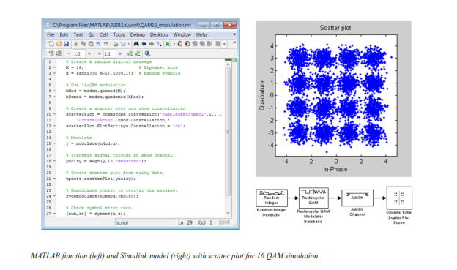

**Source and Channel Coding**

Communications System Toolbox affords source and channel coding talents that can help you develop and compare communications architectures fast, enabling you to discover what-if eventualities and avoid the need to create coding competencies from scratch.

**Source Coding**

Source coding, also referred to as quantization or signal formatting, is a manner of processing facts a good way to lessen redundancy or prepare it for later processing. The system toolbox offers a diffusion of styles of algorithms for imposing source coding and interpreting, inclusive of:

* Quantizing
* Companding (*µ*-law and A-law)
* Differential pulse code modulation (DPCM)
* Huffman coding
* Arithmetic coding

**Channel Coding**

* Orthogonal area-time block code (OSTBC) (encoder and decoder for MIMO channels)
* Turbo encoder and decoder examples

The gadget toolbox offers application functions for developing your personal channel coding. You can create generator polynomials and coefficients and syndrome deciphering tables, in addition to product parity-take a look at and generator matrices.

The system toolbox additionally presents block and convolutional interleaving and deinterleaving functions to reduce facts errors as a result of burst mistakes in a conversation machine:

**Block,** including General block interleaver, algebraic interleaver, helical scan interleaver, matrix interleave, and random interleave

**Convolutional,** including General multiplexed interleaver, convolutional interleaver, and helical interleaver

**Channel Modeling and RF Impairments**

Channel Modeling

* Communications System Toolbox provides algorithms and tools for modeling noise, fading, interference, and different distortions which might be commonly found in communications channels. The system toolbox supports the subsequent styles of channels:
* Additive white Gaussian noise (AWGN)
* Multiple-enter multiple-output (MIMO) fading
* Single-enter single-output (SISO), Rayleigh, and Rician fading
* Binary symmetric

A MATLAB channel object provides a concise, configurable implementation of channel models, enabling you to

Specify parameters such as:

* Path delays
* Average path gains
* Maximum Doppler shifts
* K-Factor for Rician fading channels
* Doppler spectrum parameters
* For MIMO systems, the MATLAB MIMO channel object expands these parameters to also include:
* Number of transmit antennas (up to 8)
* Number of receive antennas (up to 8)
* Transmit correlation matrix
* Receive correlation matrix

To combat the effects noise and channel corruption, the system toolbox provides block and convolutional coding and decoding techniques to implement error detection and correction. For simple error detection with no inherent correction, a cyclic redundancy check capability is also available. Channel coding capabilities provided by the system toolbox include:

* BCH encoder and decoder
* Reed-Solomon encoder and decoder
* LDPC encoder and decoder
* Convolutional encoder and Viterbi decoder

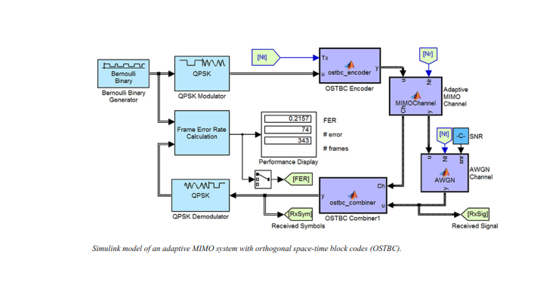

**RF Impairments**

To model the effects of a nonideal RF front end, you can introduce the following impairments into your communications system, enabling you to explore and characterize performance with real-world effects:

* Memoryless nonlinearity
* Phase and frequency offset
* Phase noise
* Thermal noise

You can include more complex RF impairments and RF circuit models in your design using SimRF.

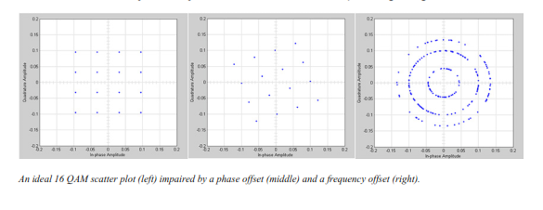

**Equalization and Synchronization**

Communications System Toolbox lets you discover equalization and synchronization strategies. These techniques are usually adaptive in nature and tough to design and symbolize. The machine toolbox affords algorithms and tools that will let you swiftly select the proper approach on your communications machine. Equalization To compare one-of-a-kind techniques to equalization, the device toolbox offers you with adaptive algorithms which include:

* LMS
* Normalized LMS
* Variable step LMS
* Signed LMS
* MLSE (Viterbi)
* RLS
* CMA

These adaptive equalizers are available as nonlinear decision feedback equalizer (DFE) implementations and as

Linear (symbol or fractionally spaced) equalizer implementations.

**Synchronization**

The device toolbox provides algorithms for each service segment synchronization and timing phase synchronization. For timing section synchronization, the machine toolbox presents a MATLAB Timing Phase Synchronizer object that offers the following implementation techniques:

* Early-late gate timing method
* Gardner’s method
* Fourth-order nonlinearity method

**Stream Processing in MATLAB and Simulink**

Most verbal exchange structures cope with streaming and frame-primarily based statistics using a aggregate of temporal processing and simultaneous multi frequency and multichannel processing. This form of streaming multidimensional processing can be visible in superior communication architectures consisting of OFDM and MIMO. Communications System Toolbox enables the simulation of advanced communications structures via helping move processing and frame-based simulation in MATLAB and Simulink. In MATLAB, circulate processing is enabled by way of System items™, which use MATLAB objects to symbolize time-based and facts-driven algorithms, sources, and sinks. System objects implicitly manipulate many information of flow processing, including information indexing, buffering, and management of set of rules state.

You can mix System gadgets with fashionable MATLAB functions and operators. Most System items have a corresponding Simulink block with the identical abilities. Simulink handles circulation processing implicitly with the aid of coping with the float of information thru the blocks that make up a Simulink model. Simulink is an interactive graphical environment for modeling and simulating dynamic systems that uses hierarchical diagrams to symbolize a machine version. It includes a library of widespread-reason, predefined blocks to represent algorithms, resources, sinks, and device hierarchy.

**Implementing a Communications System**

Fixed-Point Modeling Many communications systems use hardware that requires a fixed-point representation of your design.

Communications System Toolbox supports fixed-point modeling in all relevant blocks and System objects™ with tools that help you configure fixed-point attributes.

Fixed-point support in the system toolbox includes:

* Word sizes from 1 to 128 bits
* Arbitrary binary-point placement
* Overflow handling methods (wrap or saturation)
* Rounding methods: ceiling, convergent, floor, nearest, round, simplest, and zero

Fixed-Point Tool in Simulink Fixed Point™ facilitates the conversion of floating-point data types to fixed point. For configuration of fixed-point properties, the tool tracks overflows and maxima and minima.

**Code Generation**

Once you've got advanced your set of rules or communications device, you can robotically generate C code from it for verification, rapid prototyping, and implementation. Most System gadgets, functions, and blocks in Communications System Toolbox can generate ANSI/ISO C code the use of MATLAB Coder™, Simulink Coder™, or Embedded Coder™. A subset of System gadgets and Simulink blocks also can generate HDL code. To leverage present highbrow belongings, you can choose optimizations for specific processor architectures and integrate legacy C code with the generated code.

You can also generate C code for both floating-point and fixed-point data types.

DSP Prototyping’s are used in communication system implementation for verification, rapid prototyping, or final hardware implementation. Using the processor-in-the-loop (PIL) simulation capability found in Embedded Coder, you can verify generated source code and compiled code by running your algorithm’s implementation code on a target processor. FPGA PrototypingFPGA is used in communication systems for implementing high-speed signal processing algorithms. Using the FPGA-in-the-loop (FIL) capability found in HDL Verifier™, you can test RTL code in real hardware for any existing HDL code, either manually written or automatically generated HDL code.

**CHAPTER 9**

**EXPERIMENTAL RESULTS**

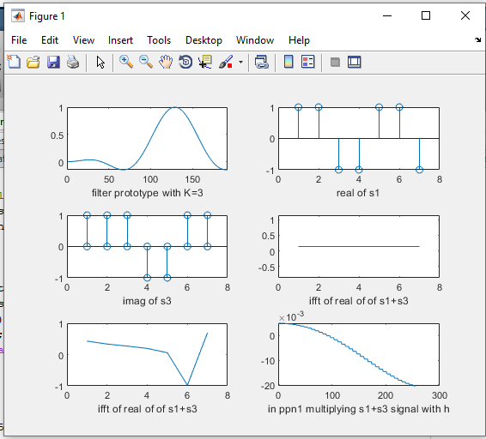

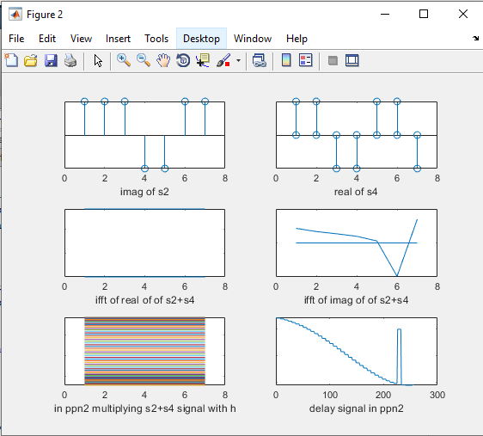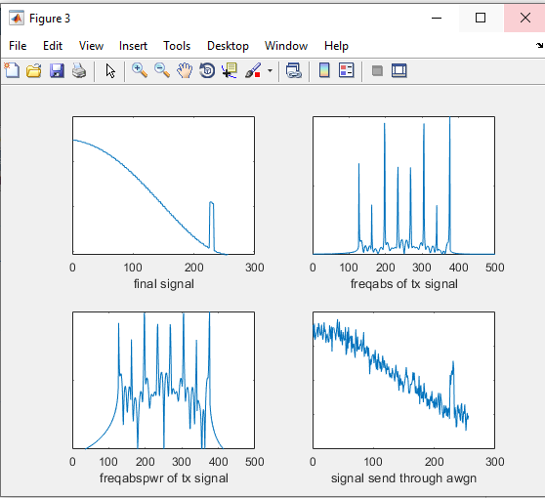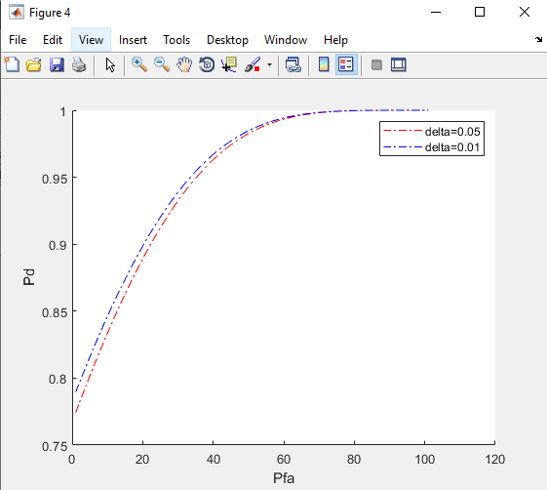

Fig.: Receiver operating characteristic (ROC) curves

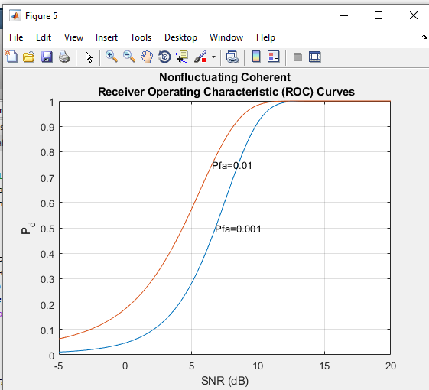

Fig. : PD Vs SNR [dB] plot for FBMC signal for PFA =0.01 and pfa=0.001

**CHAPTER10**

**CONCLUSION**

We have demonstrated that FBMC signal does not have any autocorrelation property. However, after suitably modifying the received signal, the autocorrelation property is clearly visible. This property is used to differentiate between noise-only and FBMC-plus-noise scenarios. A detector is proposed and distribution of test statistic under the noise only scenario is derived so that the threshold for the Neyman- Pearson detector can be designed. It is demonstrated that the proposed autocorrelation detector has good performance. Further research would be carried out to analyze the performance of the detector under unknown noise variance scenario.

**CHAPTER 11**

**REFERENCES**

[1] G. Wunder, P. Jung, M. Kasparick, T. Wild, F. Schaich et al., “5GNOW: non-orthogonal, asynchronous waveforms for future mobile applications,” IEEE Communications Magazine, vol. 52, no. 2, pp. 97–105, February 2014.

[2] B. Farhang-Boroujeny, “Filter bank multicarrier modulation: A waveform candidate for 5G and beyond,” Advances in Electrical Engineering, 2014.

[3] ——, “OFDM versus filter bank multicarrier,” IEEE signal processing magazine, vol. 28, no. 3, pp. 92–112, 2011. [4] PHYDAS, “Physical layer for dynamic spectrum access and cognitive radio,” Online, 2010, (Accessed: Apr. 2016). [Online]. Available: <http://www.ict-phydyas.org/>

[5] M. Bellanger, D. Le Ruyet, D. Roviras, M. Terre, J. Nossek, L. Baltar, ´ Q. Bai, D. Waldhauser, M. Renfors, T. Ihalainen et al., “FBMC physical layer: a primer,” PHYDYAS, January, 2010.

[6] S. Chaudhari, “Spectrum sensing for cognitive radios: Algorithms, performance and limitations,” Ph.D. dissertation, Aalto University School of Electrical Engineering, Nov. 2012.

[7] B. Gao, J.-M. Park, Y. Yang, and S. Roy, “A taxonomy of coexistence mechanisms for heterogeneous cognitive radio networks operating in TV white spaces,” IEEE Wireless Communications, vol. 19, no. 4, pp. 41–48, Aug. 2012.

[8] J.-B. Dore, R. Gerzaguet, N. Cassiau, and D. Ktenas, “Waveform ´ contenders for 5G: Description, analysis and comparison,” Physical Communication, 2017.

[9] R. Tandra and A. Sahai, “SNR Walls for Signal Detection,” IEEE J. of Sel. Topics in Signal Process., vol. 2, no. 1, pp. 4–17, 2008.

[10] H. Zhang, D. Le Ruyet, and M. Terre, “Spectral correlation of multicarrier modulated signals and its application for signal detection,” EURASIP Journal on Advances in Signal Processing, vol. 2010, no. 1, p. 1, 2009.

[11] M. Aldababseh, “Channel estimation for FBMC/OQAM wireless system based on Kalman filter,” Master’s thesis, Al-Quds University, 2010.

[12] U. Madhow, Introduction to Communication Systems. Cambridge, 2014.

[13] M. G. Bellanger, “Specification and design of a prototype filter for filter bank based multicarrier transmission,” in IEEE International Conference on Acoustics, Speech, and Signal Processing, 2001, (ICASSP’01)., vol. 4. IEEE, 2001, pp. 2417–2420.

[14] W. Y. Chen, DSL Simulation Techniques and Standards Development for Digital Subscriber Line Systems, Macmillan Publishing, Indianapolis, Ind, USA, 1998.

[15] J. C. T. Starr and P. Silverman, Understanding Digital Subscriber Line Technology, Prentice Hall, Upper Saddle River, NJ, USA, 1999.

[16] R. V. Nee and R. Prasad, OFDM for Wireless Multimedia Communications, Arthec House, Boston, Mass, USA, 2000.

[17] Y. Li and G. Stüber, Eds., Orthogonal Frequency Division Multiplexing for Wireless Communications, Springer, New York, NY, USA, 2006.

[18]M. Morelli, C.-C. J. Kuo, and M.-O. Pun, “Synchronization techniques for orthogonal frequency division multiple access (OFDMA): a tutorial review,” Proceedings of the IEEE, vol. 95, no. 7, pp. 1394–1427, 2007.

[19] D. Huang and K. B. Letaief, “An interference-cancellation scheme for carrier frequency offsets correction in OFDMA systems,” IEEE Transactions on Communications, vol. 53, no. 7, pp. 1155–1165, 2005.

[20] K. Lee and I. Lee, “CFO compensation for uplink OFDMA systems with conjugated gradient,” in Proceedings of the IEEE International Conference on Communications (ICC '11), pp. 1–5, Kyoto, Japan, June 2011.

[21] K. Lee, S.-R. Lee, S.-H. Moon, and I. Lee, “MMSE-based CFO compensation for uplink OFDMA systems with conjugate gradient,” IEEE Transactions on Wireless Communications, vol. 11, no. 8, pp. 2767–2775, 2012.

[22] A. Farhang, N. Marchetti, and L. E. Doyle, “Low complexity LS and MMSE based CFO compensation techniques for the uplink of OFDMA systems,” in Proceedings of the IEEE International Conference on Communications (ICC '13), pp. 5748–5753, IEEE, Budapest, Hungary, June 2013.

[23] H. Saeedi-Sourck, Y. Wu, J. W. M. Bergmans, S. Sadri, and B. Farhang-Boroujeny, “Complexity and performance comparison of filter bank multicarrier and OFDM in uplink of multicarrier multiple access networks,” IEEE Transactions on Signal Processing, vol. 59, no. 4, pp. 1907–1912, 2011.